# **Measures of Association**

## **Support**

## **Confidence Lift**

## **Apriori Algorithm**

### **Eg-1**

### **Eg-2**

### **Eg-3**

### **Eg-4**

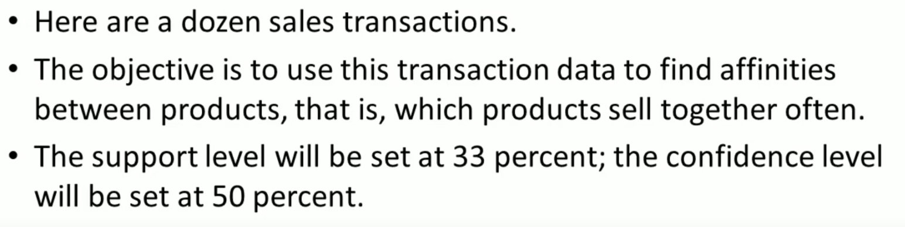

Number of transactions 🡪 12

Minimum Support 🡪 33%

(33 / 100) * 12 = 3.96 ~ 4  
Confidence 🡪 50%

(50 / 100) * 12 = 6

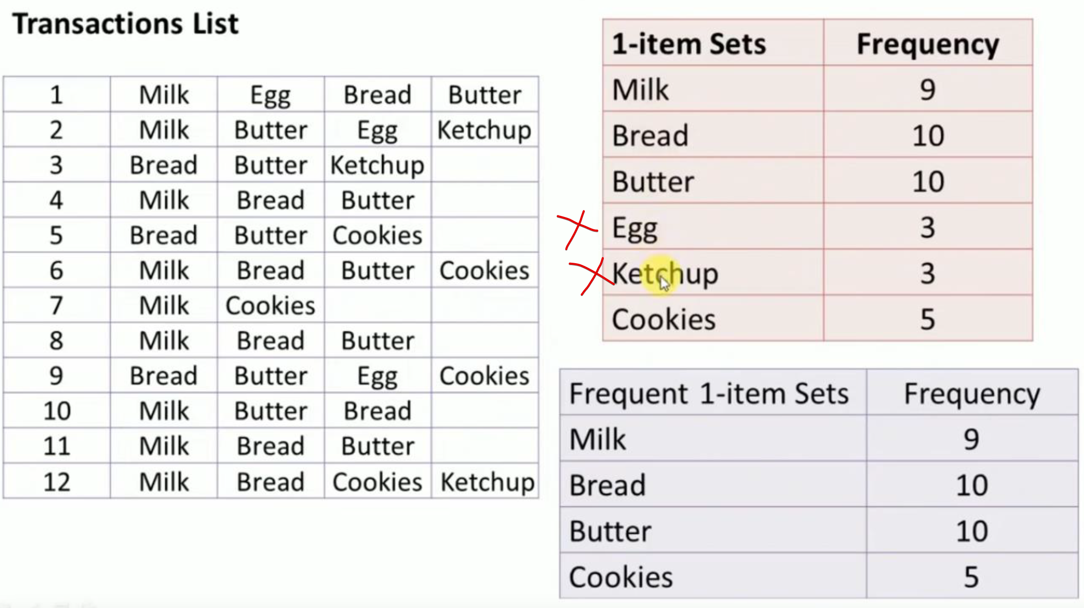

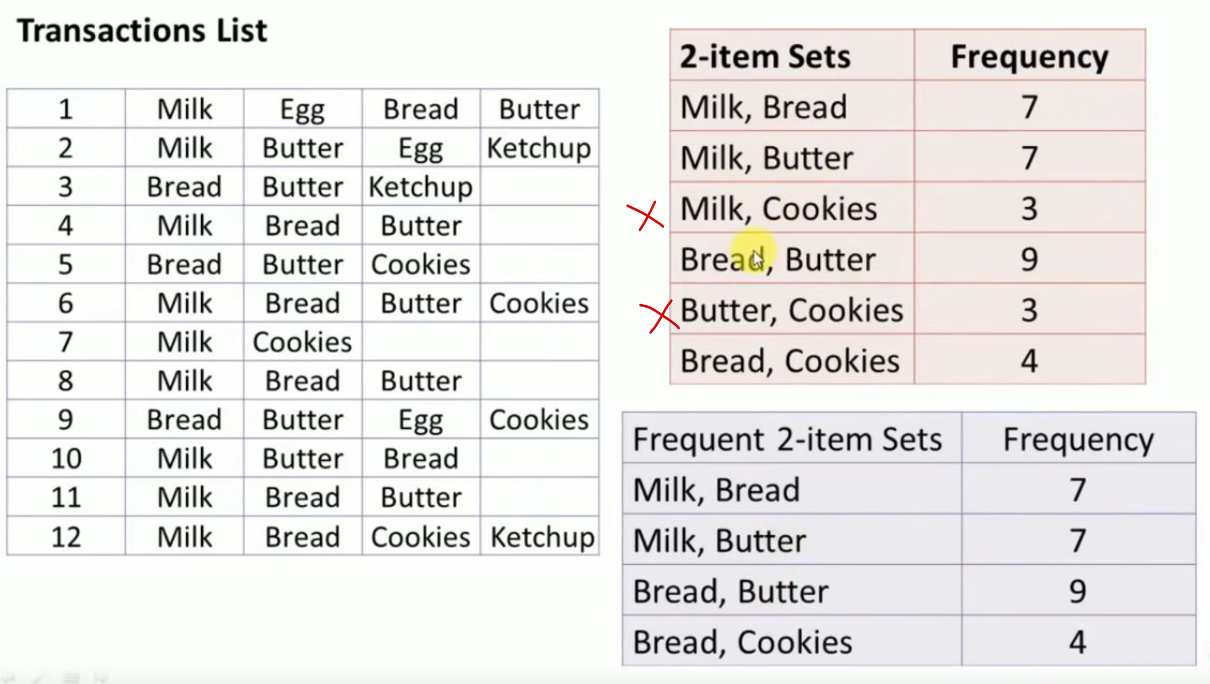

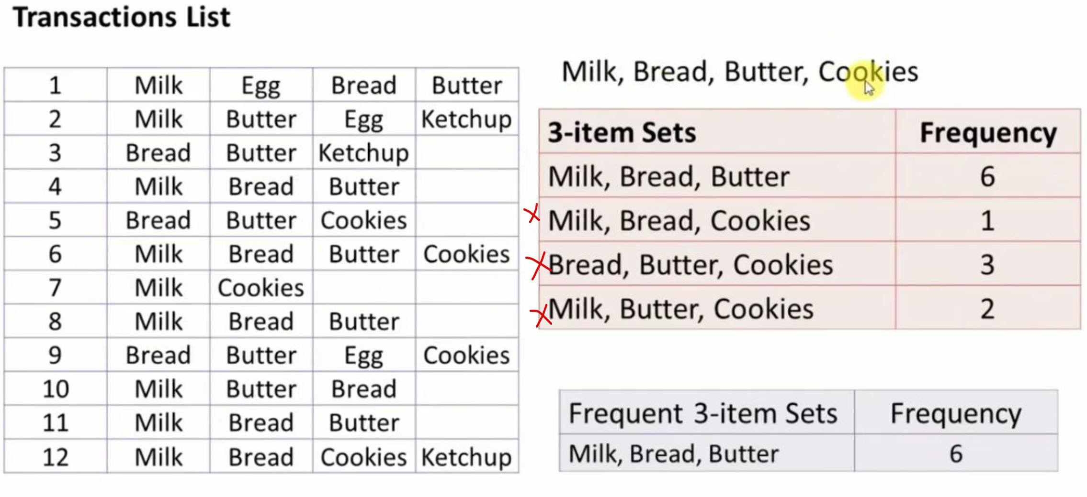

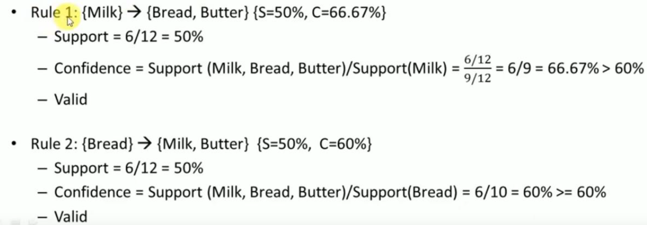  
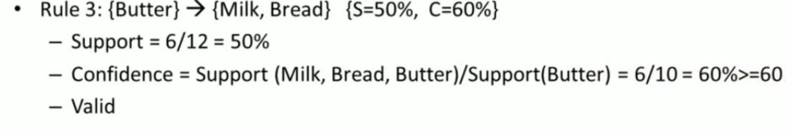

Do the above thing in reverse-way.

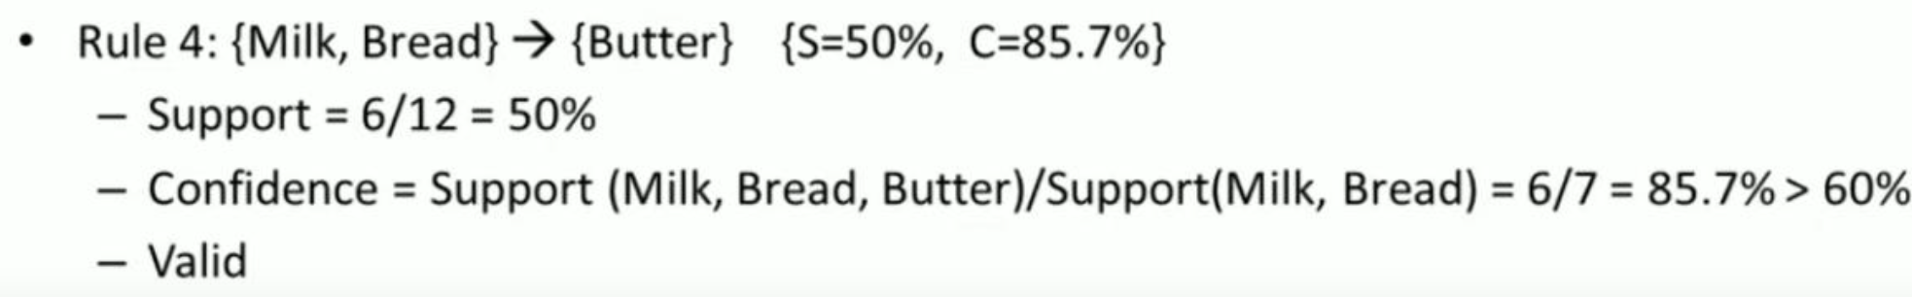  
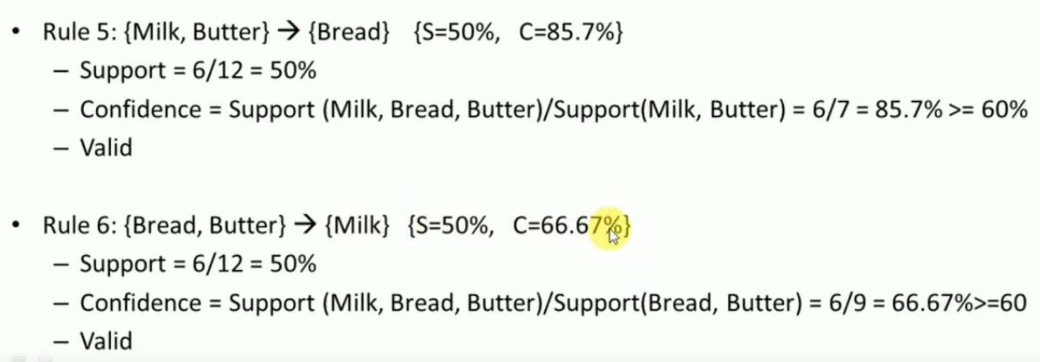

## **FP-Growth**

### **Eg-1**

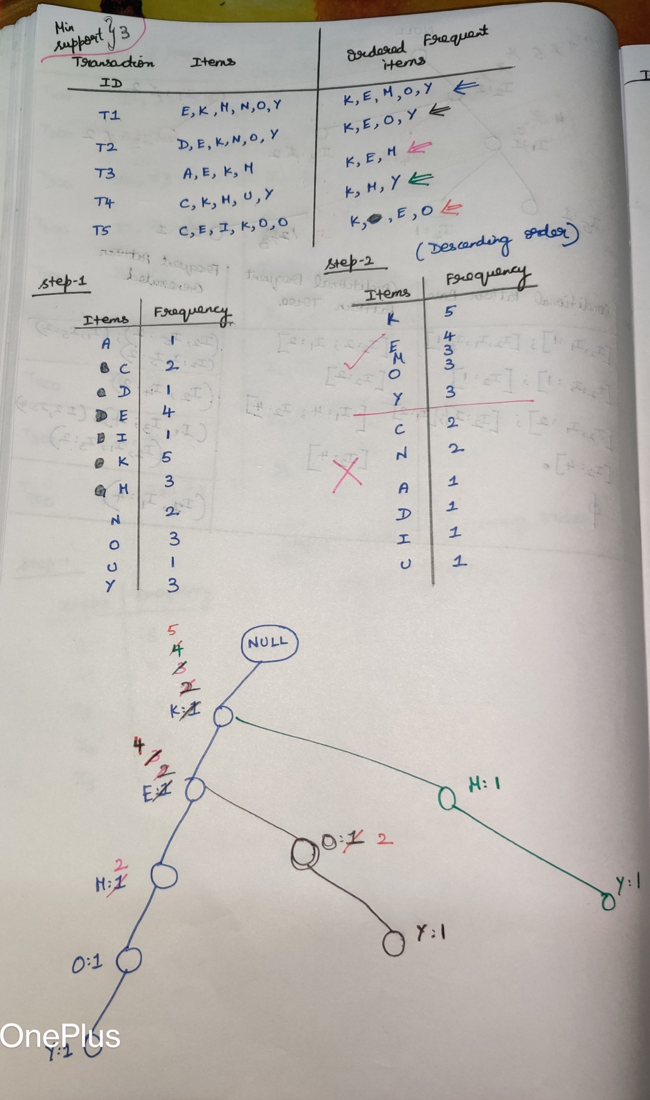

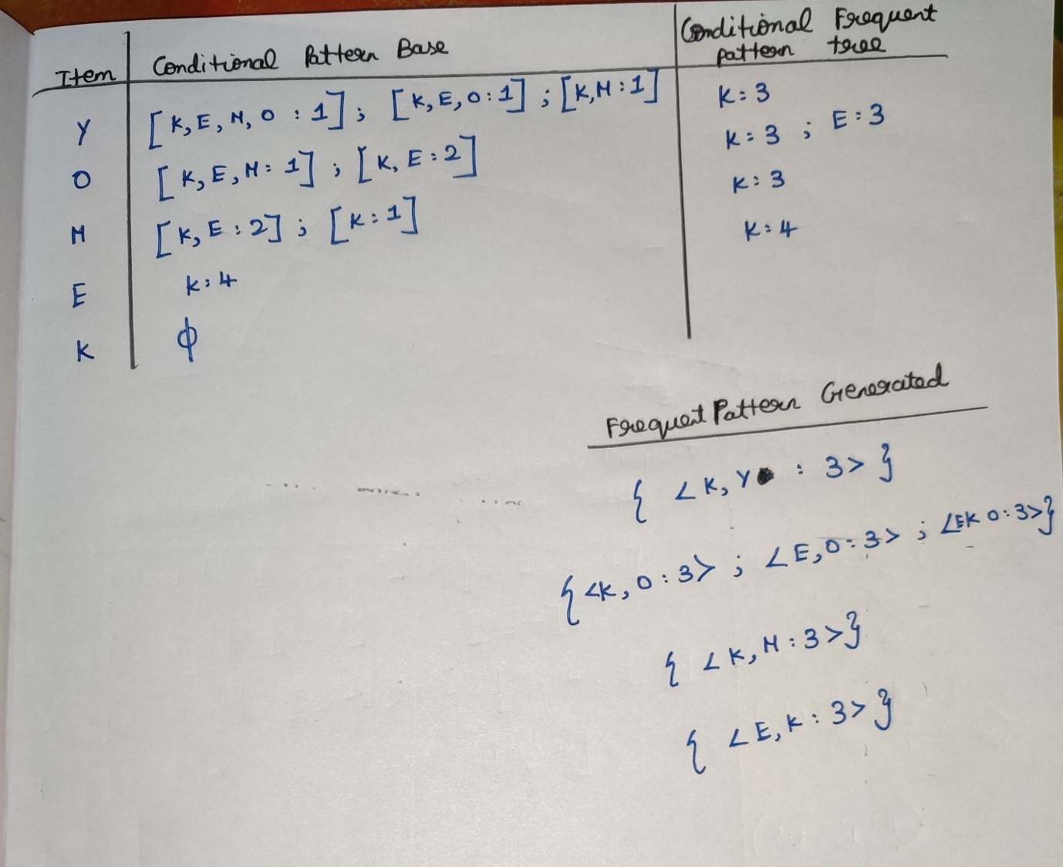

### **Eg-2**

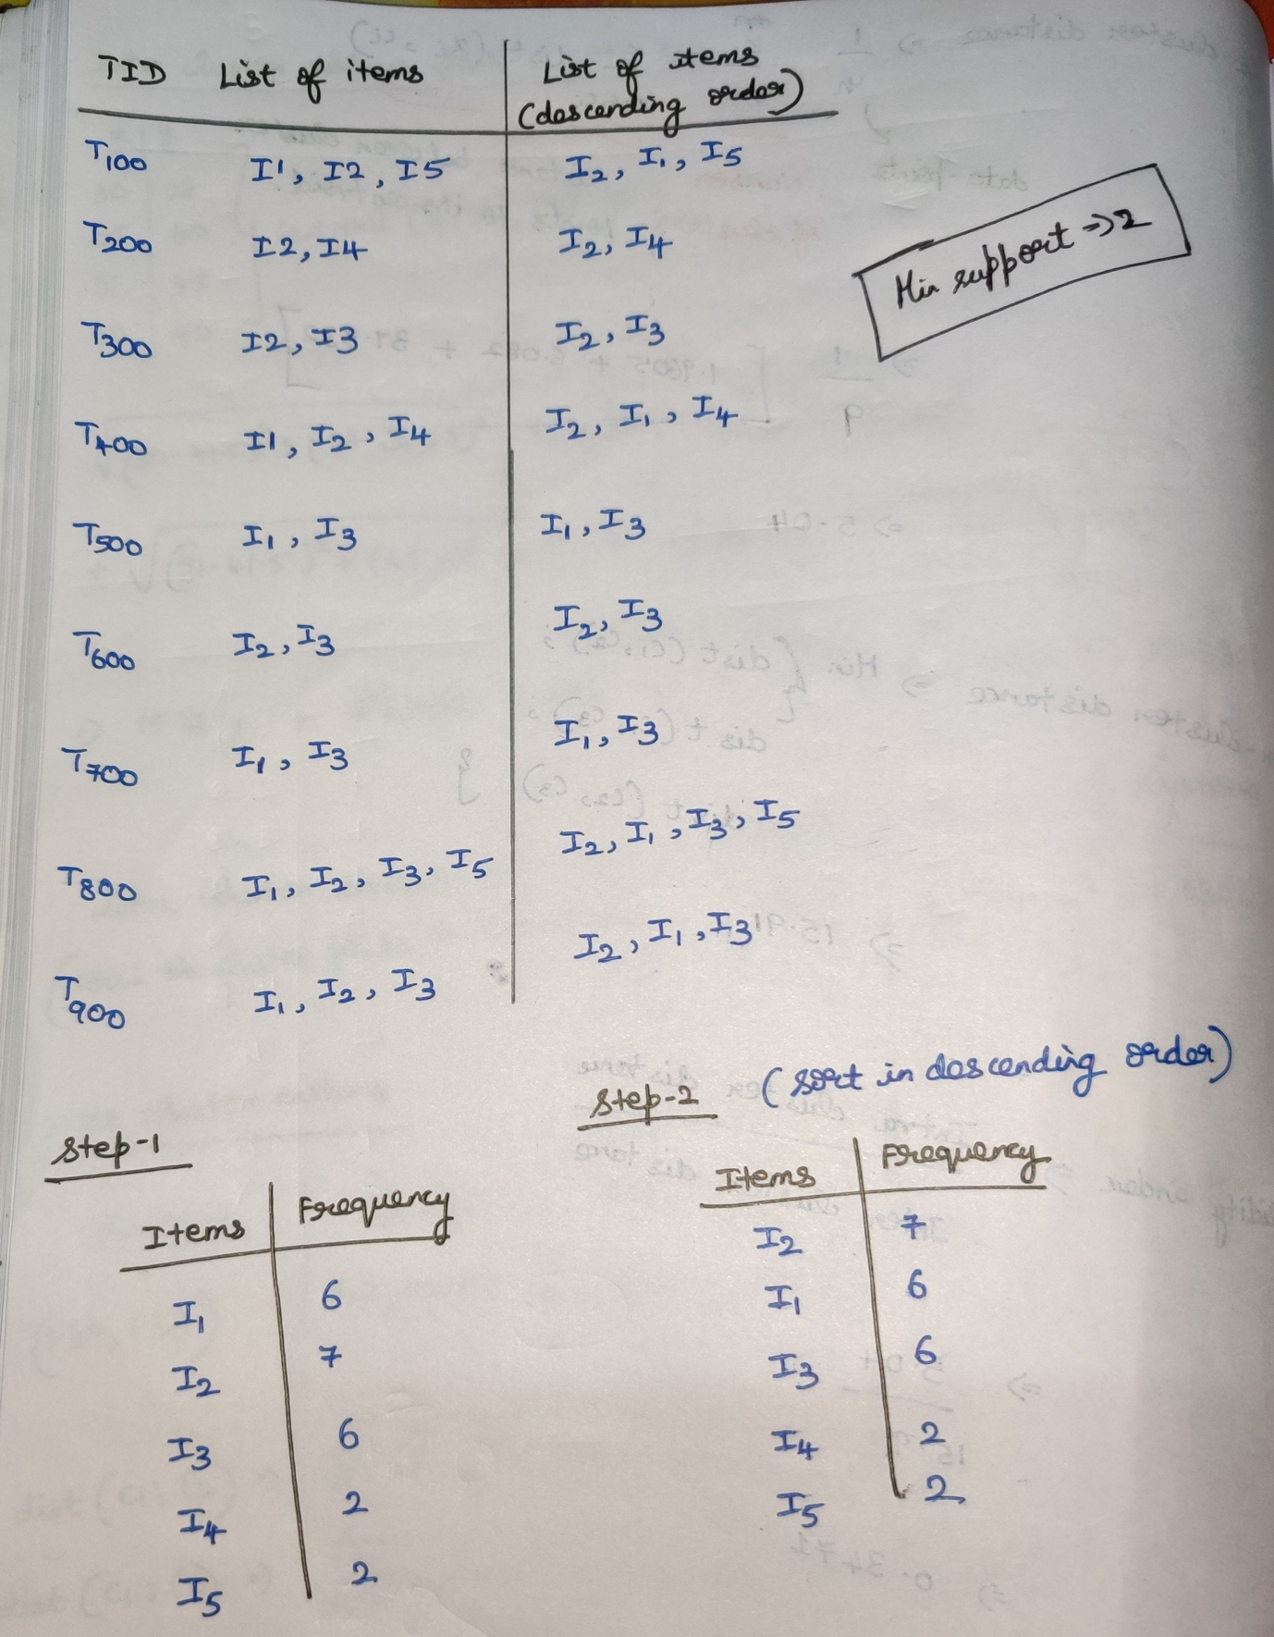

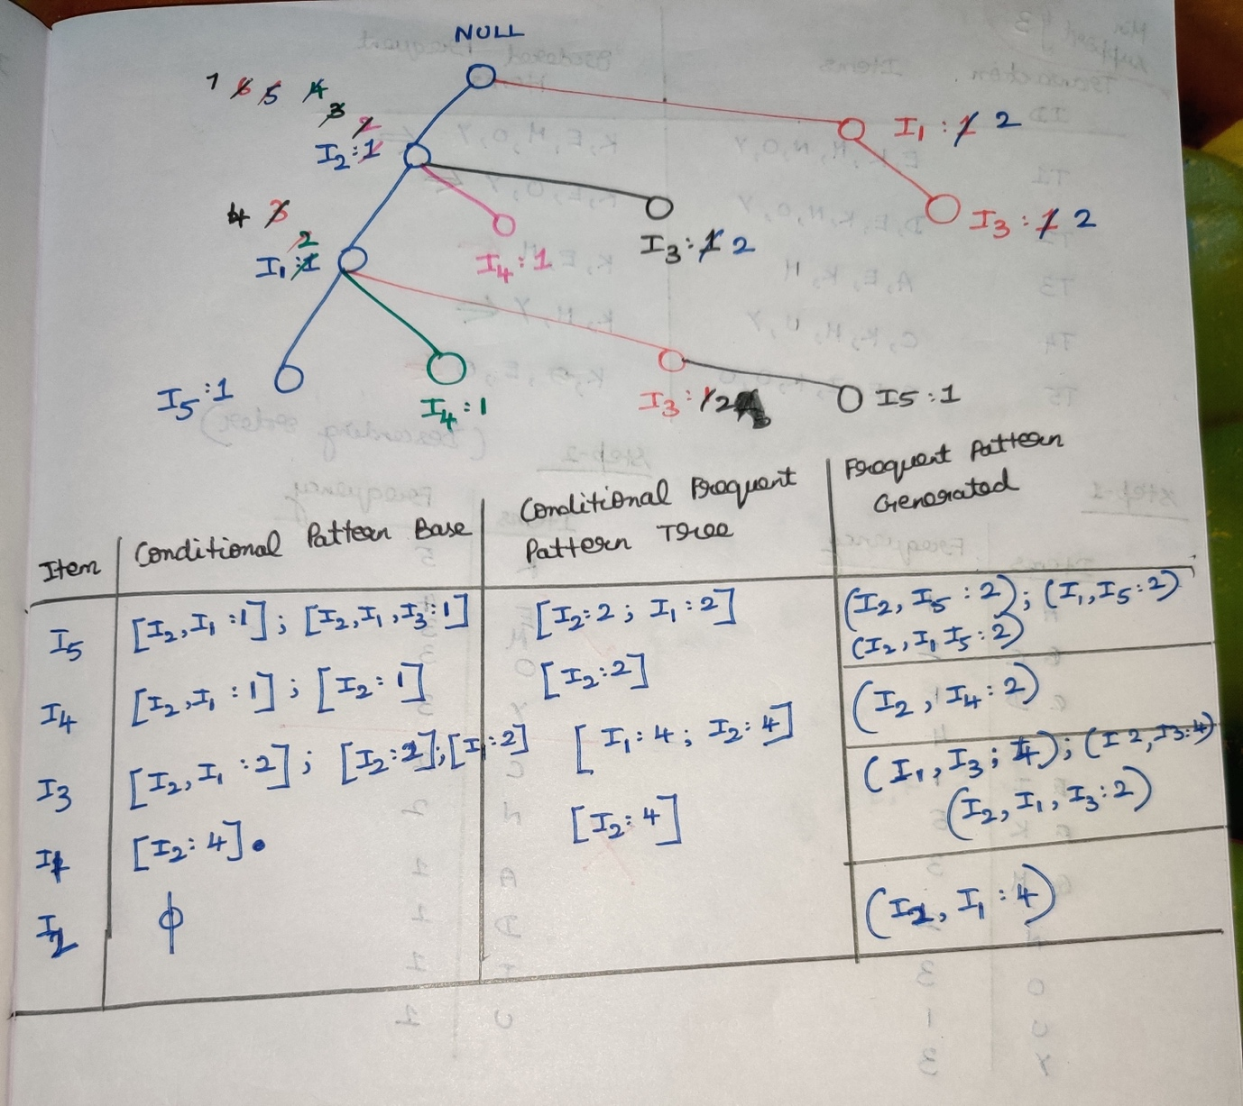

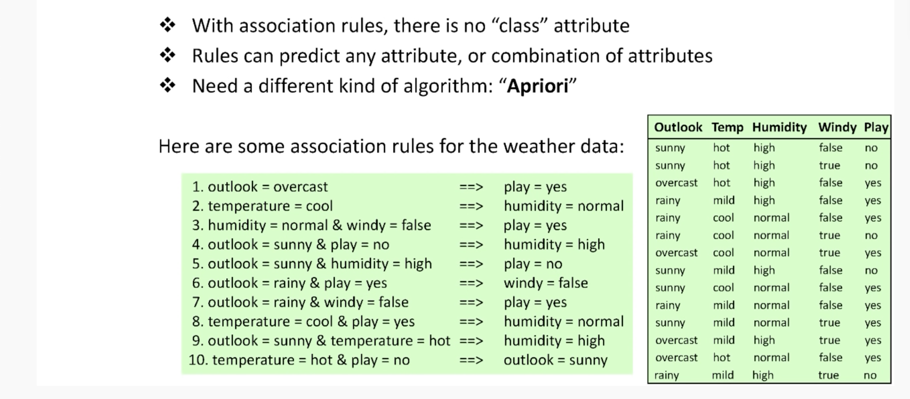

There are 336 rules that are 100% correct.

All these are 100% confident but with different degrees of support.  
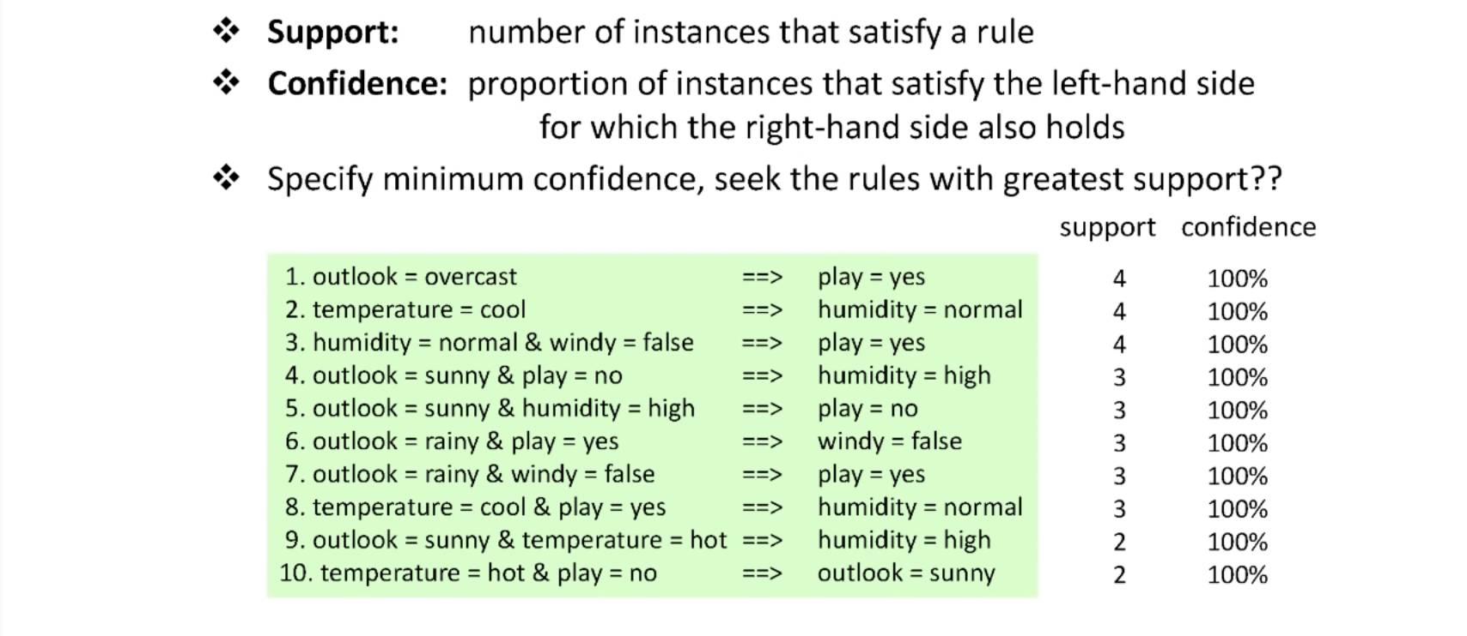

These are the rules having 100% confidence but they have different degrees of support.

Extract the rules having minimum degree of confidence with greatest support.

